npm install -g @vue/cli

vue create projectName

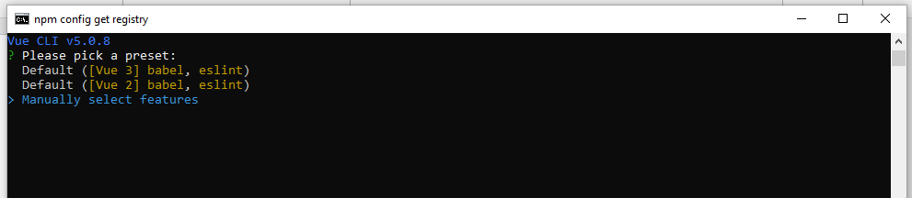

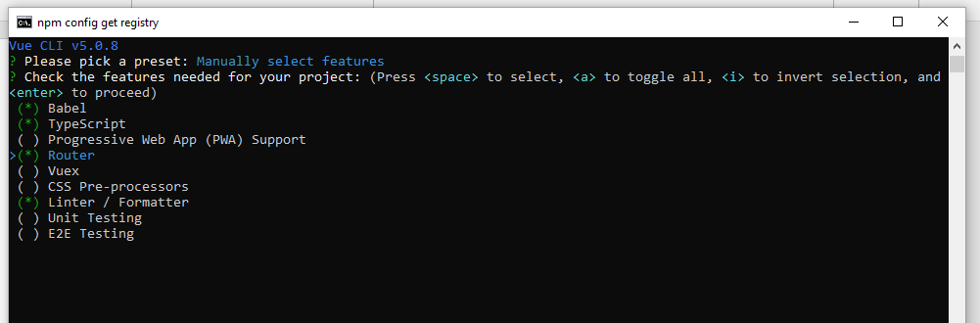

Have to select from keyboard 1,2,4,7

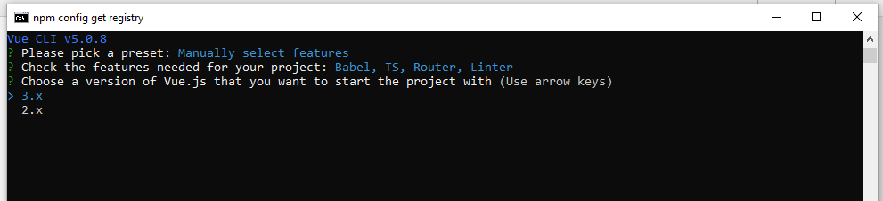

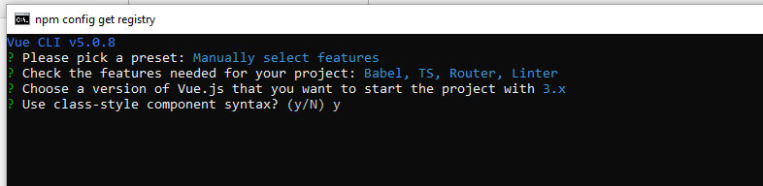

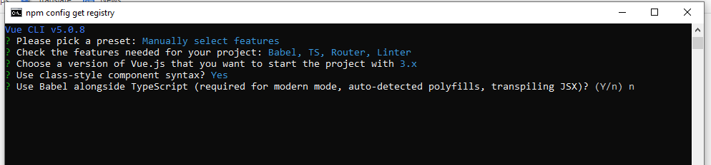

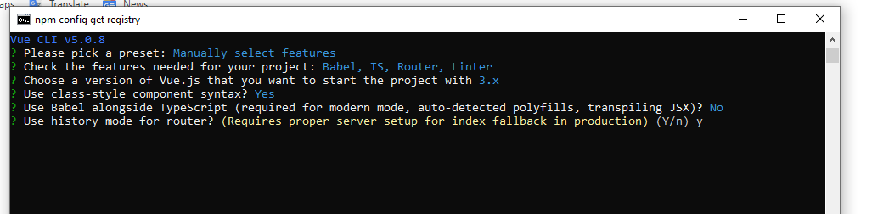

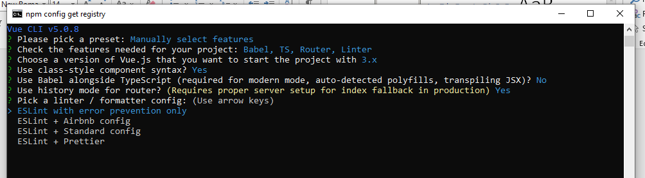

For format, have to select it.

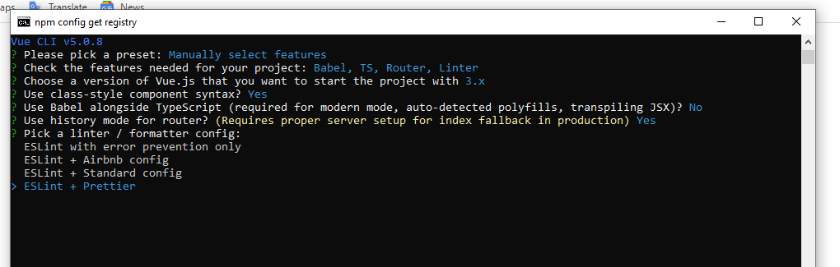

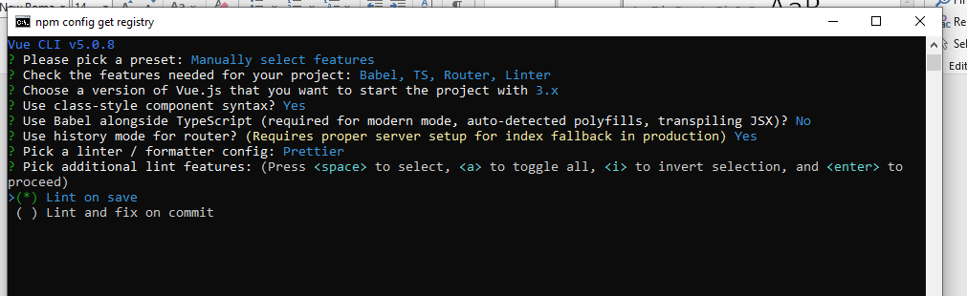

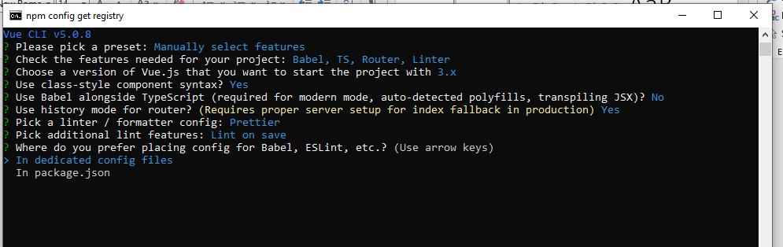

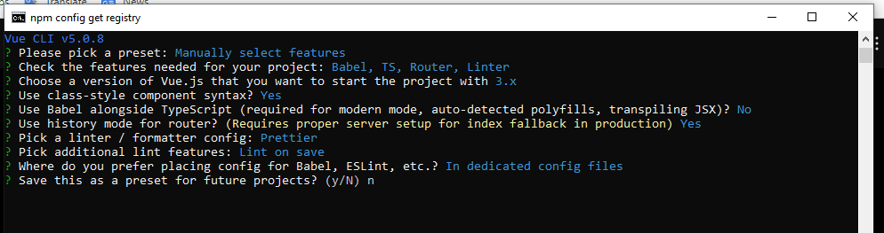

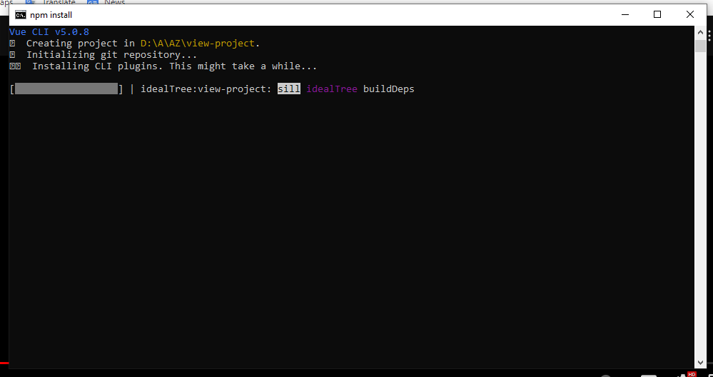

npm install

npm install -g typescript

npm i axios

create a **json server** folder and **db.json** file

**for install json server have to install =>** npm i json-server

**for global install the server =>** npm install -g json-server

**Folder open kore cmd te project run korte hobe.**

**for run the server =>** json-server --watch db.json

Create a db.json file with some data

{

"posts": [

{ "id": 1, "title": "json-server", "author": "typicode" }

],

"comments": [

{ "id": 1, "body": "some comment", "postId": 1 }

],

"profile": { "name": "typicode" }

}

F**or run the project =>** npm run serve

Npm run build

Npm run dev